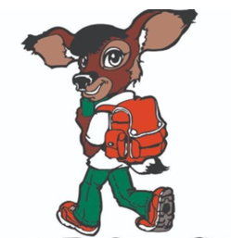**2nd Grade Supply List and Tips** 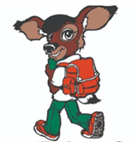

* Backpack (**please label**)
* 1 pair of Headphones (**please label**)
* 2 Packs of #2 Pencils **(NO mechanical pencils)**
* 1 pack of colored pencils/crayons
* 2 composition notebooks
* Pencil Box **(please label)**
* 1 pair of kid-friendly scissors
* 1 pack of erasers
* 2 glue sticks
* 1 pack of Construction Paper
* 2 Pocket **Plastic** Folders with Prongs

**\*\*Classroom Donations\*\***

* 1 box quart sized Ziploc Bags
* 1 box gallon sized Ziplock bags
* Boxes of Kleenex
* Bottles of Sanitizer (Do not label)
* Lysol wipes
* Individually wrapped snacks/treats

**Note: Supplies should be brought during the first week of school, preferably the first day. Most supplies will be for classroom use, please do not label. Supplies will be kept at school, please purchase additional items to be used at home to complete homework assignments.**